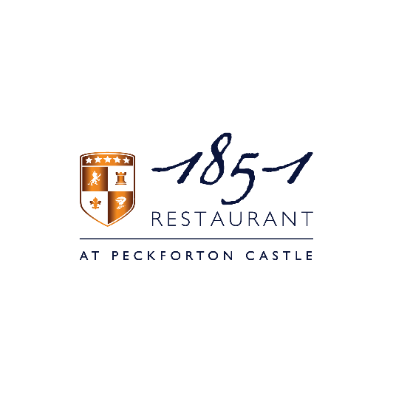
Please be aware that our dishes are prepared in kitchens where nuts & gluten are present, therefore we cannot guarantee that any food is completely free from traces. Please note menu descriptions do not always display all ingredients and allergens.
A service charge of 10% will be added to your bill. Please ask your server if you would like this to be removed

White Tomato Soup
Creme Fraiche and Tomato Fondue
Champagne - Joseph Perrier – Cuvée Royale – Brut

BBQ Jersey Royal Potatoes
Aged Cheddar and Garlic

Smoked Haddock
Puffed Rice, Curry Foam.
Pinot Gris – Matahiwi Estate – Wairarapa

Roasted Rhug Estate Chicken
Crispy Anna Potatoes, Onion Puree, Brassicas, Jus Gras

Mixed Summer Berry Infusion
Caramelised White Chocolate Ice Cream
Otto Gorgen – Riesling – Spätlese

Menu £50 / Wine Pairing £35

