N I B B L E S
O L I V E S & A L M O N D S – Mixed marinated olives & roasted salted almonds. 5
F R E S H L Y B A K E D B R E A D – Served with salted farmhouse butter. 4.5
C R I S P Y W H I T E B A I T – Served with tartar sauce, fennel salad & lemon dressing. 6.5

T O S T A R T
H O M E M A D E S O U P O F T H E D A Y – Please ask your server for today’s choice. 8
P E C K F O R T O N F R I E D C H I C K E N – Southern fried boneless strips with sesame oil & siracha mayonnaise. 9
L I M E & C H I L L I B B Q K I N G P R A W N S – Chilli chutney, toasted sourdough. 12
H A R R I S A B A K E D B A B Y A U B E R G I N E – Harrisa yoghurt, pomegranate molasses, coriander & wild rice. 9

C O L D S A N D W I C H E S – All served with a choice of white or brown bread, crisps & slaw. Served until 18.00.
R O A S T H A M & M U S T A R D M A Y O N N A I S E 8
C O R O N A T I O N C H I C K E N 9
I S L E O F M U L L C H E D D A R & S P R I N G O N I O N 8
S M O K E D S A L M O N & D I L L C R E A M C H E E S E 10

H O T S A N D W I C H E S – All served with skin on fries & slaw. Served until 18.00.
B L T – Bacon, gem lettuce, tomato, mayonnaise & cracked black pepper served on toasted loaf. 13
C O D G O U J O N ‘B U T T Y’ – Crispy cod goujons, gem lettuce, tartar sauce & lemon. 14
A V O C A D O C L U B – Roasted red peppers, sliced avocado, plum tomato, gem lettuce. 12

Please be aware that our dishes are prepared in kitchens where nuts & gluten are present, therefore we cannot guarantee that any food is completely free from traces. Please note menu descriptions do not always display all ingredients and allergens.Should you require any further information regarding allergens, please speak to a member of our team before ordering.
A service charge of 10% will be added to your bill. Please ask your server if you would like this to be removed.

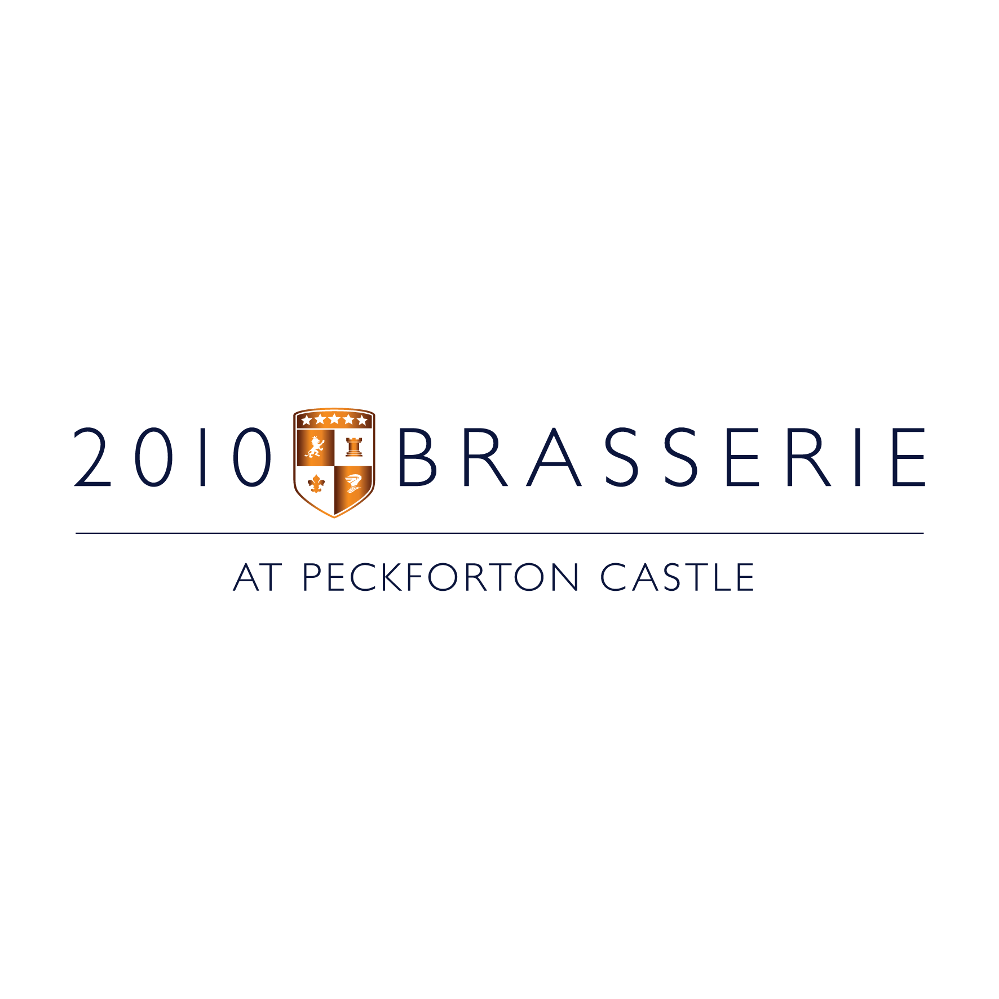

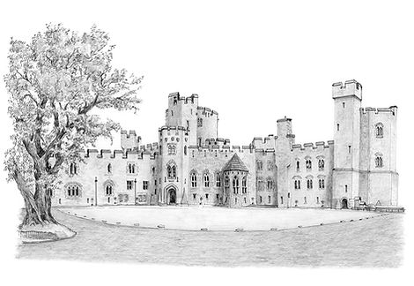
B U R G E R S – All served with skin on fries & slaw
C R I S P Y G O A T S C H E E S E C R O T T I N – Gem lettuce, red pepper relish & beetroot glaze. 16
8 o z H E R E F O R D S H I R E B E E F – Gem lettuce, tomato, red onion, gherkin & relish. 17.5
H O U S E F R I E D C H I C K E N – Gem lettuce, red onion, garlic mayonnaise. 16
applewood. [+4]

P R I M E A G E D S T E A K S – Served with confit tomatoes and garlic & herb mushroom.
8 o z P R I M E R U M P 23
8 o z P R I M E S I R L O I N 28
8 o z P R I M E R I B E Y E 30
S U R F & T U R F – Two chilli & lime tiger king prawns [+5]
P E P P E R C O R N S A U C E [+3]
B L U E C H E E S E S A U C E [+3]
R E D W I N E J U S [+3]
M A I N C O U R S E
C A R B O N A R A – Parmesan linguine, smoked pancetta & oregano. {Add chicken or tiger prawns [+5]} 17
P E C K F O R T O N F I S H & C H I P S – Battered cod fillet, traditional mushy peas, tartar sauce, triple cooked chips. 18
W I L D M U S H R O O M R I S O T T O– Sautee wild mushroom, pickled mushroom, Italian hard cheese, truffle, shoots. 16
S A G E & P A R M E S A N G N O C C H I – Roasted squash, confit garlic cream & sage toasted panko. 16
A V O C A D O C A E S A R S A L A D – Crisp gem lettuce, croutons, cucumber, garlic & parmesan dressing 14
{Add chicken [+5]}

S I D E S
B B Q D U S T E D F R I E S 5
P A R M E S A N & T R U F F L E C H I P S 6
C A E S A R S A L A D 5
G A R L I C B U T T E R E D B R O C C O L I 5
C A R R A W A Y & H O N E Y G L A Z E D C A R R O T S 5
B U T T E R E D M A S H E D P O T A T O 5

Please be aware that our dishes are prepared in kitchens where nuts & gluten are present, therefore we cannot guarantee that any food is completely free from traces. Please note menu descriptions do not always display all ingredients and allergens. Should you require any further information regarding allergens, please speak to a member of our team before ordering.
A service charge of 10% will be added to your bill. Please ask your server if you would like this to be removed.

